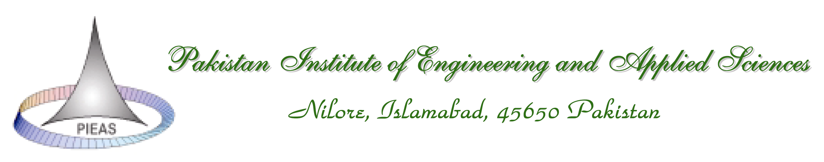
CGSR/FORM MS 2013-01

Conversion from “MS/MPhil leading to PhD” to PhD

Student’s Name: ________________________________ | Department: _________________
Registration Number: ________________________________ | Date of Registration: _____________

Sr. No. | Course Name | Course Code | Credit Hours | GPA
1.
2.
3.
4.
5.
6.
7.
8.
9.
10.
CGPA
I have completed 30 credit hours with minimum CGPA of 3.00 as detailed above. The courses were specified by the department for the conversion of MS/MPhil program to PhD program (copy attached). I have also passed NTS (Subject) with the accumulative score of _____ (copy attached).
It is requested that the conversion from MS/MPhil leading to PhD program to PhD program may kindly be allowed.

Student Name: ______________________________ Signature/Date: ____________
Supervisor’s Name: ___________________________ Signature/Date: ____________
Head of the Department (Name): _________________ Signature/Date: ____________
Dean (Research)

