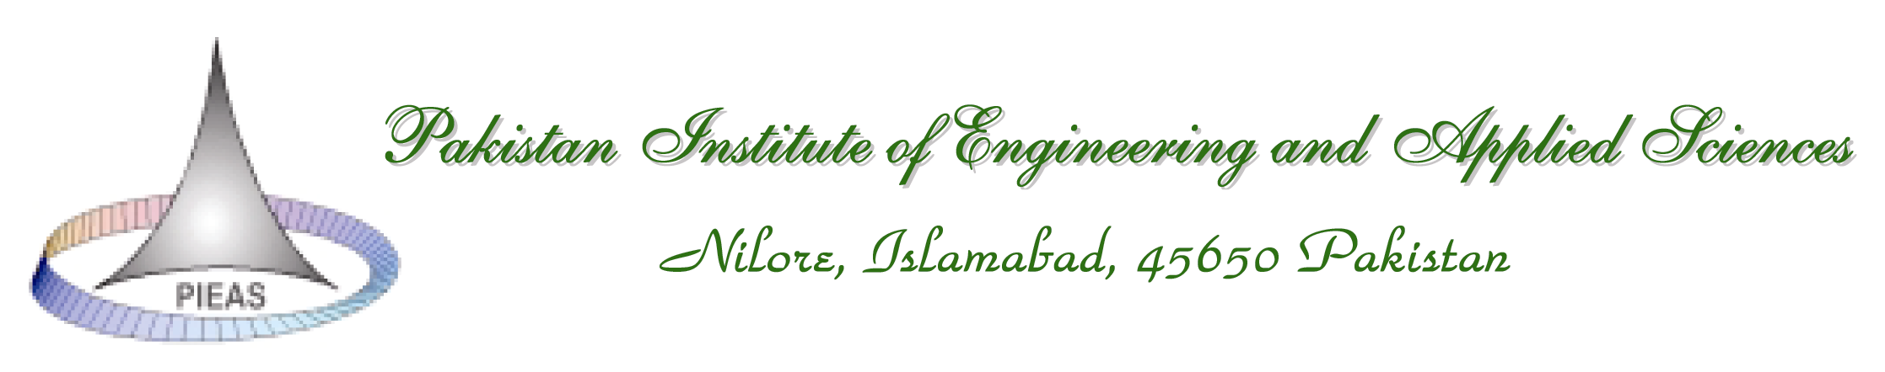
CGSR/FORM 13– PHD – 04

Report of Comprehensive PhD Qualifying Examination

Student’s Name: | Department:
Registration Number: | Date of Registration:
Thesis Title: _______________________________________________________________

This is certified that the student has passed 18 credit hour PhD courses approved in the plan of study with minimum required CGPA of 3.0. A comprehensive qualifying examination has been conducted based on the PhD courses, and the following is being submitted.

Basis for this report (tick the appropriate box):
WRITTEN EXAMINATIONS | FIRST ATTEMPT |  | SECOND ATTEMPT

Result of the Examination:

% Marks Obtained
Pass / Fail

Approved by Head of the Department:

Name: ___________________________ | Signature: ____________________________

Date: ___________________

Enclosures: Date-Sheet, Question Paper and the Answer Sheet

Distributions:
- Original copy should be forwarded to Dean (Research) for student’s personal file.
- Dean and Head of the department’s office for record.

