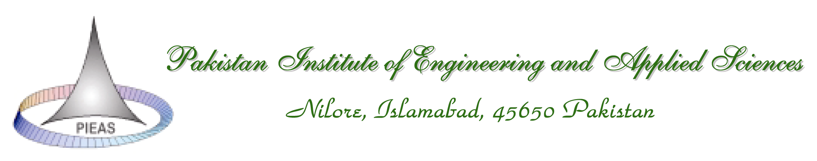
CGSR/FORM 15– PHD – 11

PhD Thesis Evaluation Report

Student’s Full Name:
Title of the Thesis:

TO BE COMPLETED BY THE REVIEWER
(Please Tick ☑ appropriately)

Please mark the student’s research work in terms of the following:
- Structure and Organization of the Thesis.
Appropriate Inappropriate

- Abstract
Appropriate Inappropriate

- Introduction
Appropriate Inappropriate

- Problem Statement / Background of the Problem
Clearly stated / Not clearly stated

- Literature Review
Relevant Irrelevant

Coverage: Critical Analysis:

- Scientific Methodology
Appropriate Partially Correct Incorrect

- Statistical Procedures (if applicable)
Appropriate Partially Correct Incorrect

- Analysis and Discussion
Appropriate: Partially Correct: Incorrect:

- Research Findings
Appropriate: Partially Correct: Incorrect:

- Quality of References
Appropriate: Inappropriate:

- Appendices
Appropriate: Inappropriate:
- Language and Grammar
Good: Needs Improvement: Poor:

- Amount of knowledge
Satisfactory: Unsatisfactory:

- Contribution to the State-of-the-Art:
Significant: Good: Fair: Unsatisfactory:

- Remarks
May use extra sheet if needed

- Conclusion
Reviewer may assign one of the three categories to the thesis given below.

Satisfactory (S): | Major Revision required (M) | Unsatisfactory (U):

Satisfactory (S):
The thesis meets the degree requirements in scope, contribution to knowledge and research methodology. Some minor improvements in one or more of the following may also be suggested: presentation and analysis of results, layout and quality of writing.

Major Revision required
The research problem considered in the thesis satisfies the requirements of a PhD degree but the thesis requires major changes in one or more of the following: scope, contribution to knowledge and research methodology. A re-evaluation of the thesis would be required in this case.

Unsatisfactory
The thesis does not satisfy the expectations and requirements for a PhD degree.

Name of Reviewer:
Affiliation:
Signature/Date:

