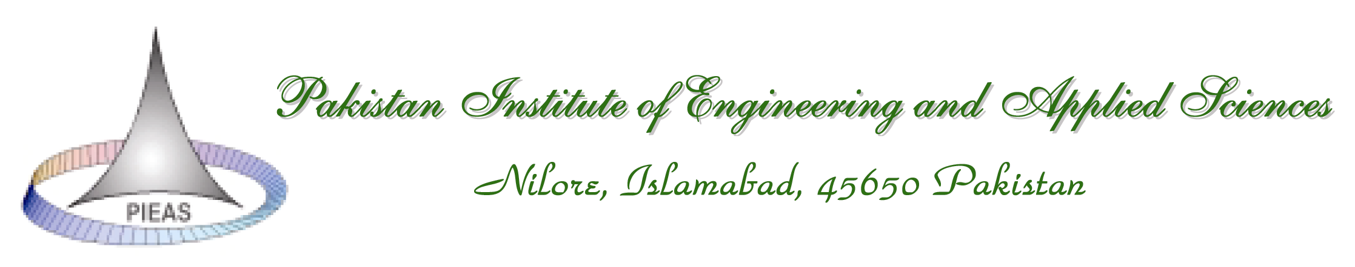
Department of Computer and Information Sciences

Dec 29, 2014

Subject: Policy for Thesis Project of M-Phil CS (session 2013-15)

Project Allocation phase:
- All supervisors should submit thesis proposal proforma before 29th December 2014.
- One supervisor can supervise up to maximum of two projects as main supervisor and two projects as co supervisor.
- The minimum qualification for a supervisor is eighteen years of education plus two years’ service.
- The minimum requirement for a co-supervisor is eighteen years of education.
- In case of external supervisor (outside DCIS), a co-supervisor will be mandatory from faculty.
- Wherever the project work is carried out (including classified establishments), the defense (only examiners and supervisor) and final presentation (open to all) will be held at PIEAS. The presence of supervisor is necessary for all presentations of fourth and fifth semesters.
- Project selection meeting will held on 9th January 2015.
  - The selection committee have the following members:
    - Head DCIS, Project Coordinator, Dr. Hanif Duraid, Dr. Naeem Akhtar and Dr. Fayyaz ul Afsar.
- DCIS/ selection committee has right to reject or accept any project.
- After project’s selection meeting, all students are required to submit Thesis Project Selection Proforma on or before 12th January 2015.
- Students will be notified about project allocations from End of January 2015.

During Forth Semester:
- All the students are requested to get the reports delivery form sign it from respective personnel and submit it to project Coordinator.
  - All the supervisors, Co-supervisors, examiners are requested to sign the form and enter the date and timings when the student hands over the report.
- Students will be evaluated during and by end of semester by supervisors and examiners.
  - Such that project work during semester (60%) and seminars (40%).

During fifth Semester:
- The fellow should submit thesis first draft as notified.
- The copy of the first draft (apply plastic covers) should be submitted to supervisors, co-supervisors (if any), external examiners and Project Coordinator.
- The thesis defense has also been notified. The guide lines for thesis defense are given below
- All the examiners should be present during defense.
- The defense shall comprise a presentation and detail question answer session.
- The examiners shall put questions. Nobody else is allowed to attend this presentation except supervisors and examiners.
- Attendance of defense examiners should be submitted by supervisor to the project coordinator.
- The result (in percentage marks) will be submitted by all the examiners to coordinator independently after the defense.
- The final thesis presentation has also been notified. The guide lines for final presentation are
- The final presentation shall be only for approved thesis.
- Final presentation shall be essential for declaration of result.
- This presentation shall be open to all.
- There should be no evaluation in final presentation.
- Faculty of the department must attend these presentations (except with the permission of HOD).
- The schedule of presentation and defense has been issued by the DCIS. Any change in this schedule, made by a supervisor, must be communicated to DCIS.
- The final thesis should be submitted as mentioned in the notice.
- The thesis should be according to the format approved by the DCIS.
- Every student is required to deposit 3 final hard bound copy of thesis to (project coordinator)
  - Project Coordinator (Three copies for Deptt, supervisor, library),
  - Co-supervisor (Optional)
  - Examiners (Optional)
  - Student Copy (compulsory)
- For any reason, if a supervisor/Project Committee feels that the performance of a student at the end of fifth semester is not up to the mark, he/she will have to continue the project work in the sixth semester, to fulfill the task requirements assigned by committee.
- Wherever the project work is carried out (including classified establishments), the defense (only examiners and supervisor) and final presentation (open to all) will be held at PIEAS.

- During the Research semester II, there will be open-to-all Final Presentations as notified. The presence of a student in 80% presentations is compulsory else his\her result may not be forwarded.
- The color of thesis binding should be Dark Blue with Silver writing.
- On the spine of the thesis, the following should be printed, Name of Student, M.Phil Computer Sciences, Session for example
Muhammad Ahmad M.Phil Computer Sciences Session 2013-15.
- The project related material should be copied in a folder (soft form) and should also be submitted to project coordinator. This folder should include
  - word file of final thesis report (or pdf in case of Latex)
  - PDF file of thesis
  - PPT file of final presentations (4th and 5th semester)
  - Complete Code
  - Reference material.
All the above mentioned files should also be copied in a separate folder burn the CD-ROM and submitted to the Project Coordinator. (Please check the CD-ROM after writing).
- Results for all Final Presentations will be finalized by the supervisors and promptly (not later than three days after a presentation) communicated to the Project Coordinator, DCIS on the prescribed form.
- The presentation time for each student is 15 minutes plus 10 minutes question answers. All the students are advised to strictly follow the presentation timings.

Project Coordinator
DCIS, PIEAS

